New design high quality waterproof golf bag
Water resistant pocket with micro-suede lining
Dual density comfort strap
Utilizes two materials for added comfort and stability
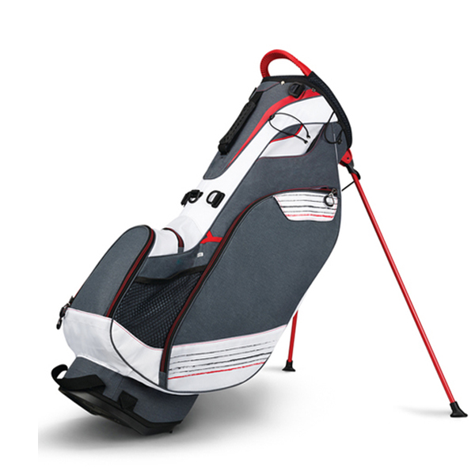

More information please click: www.tt-golf.com

